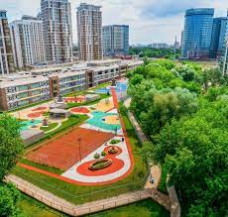
About Brookes Moscow

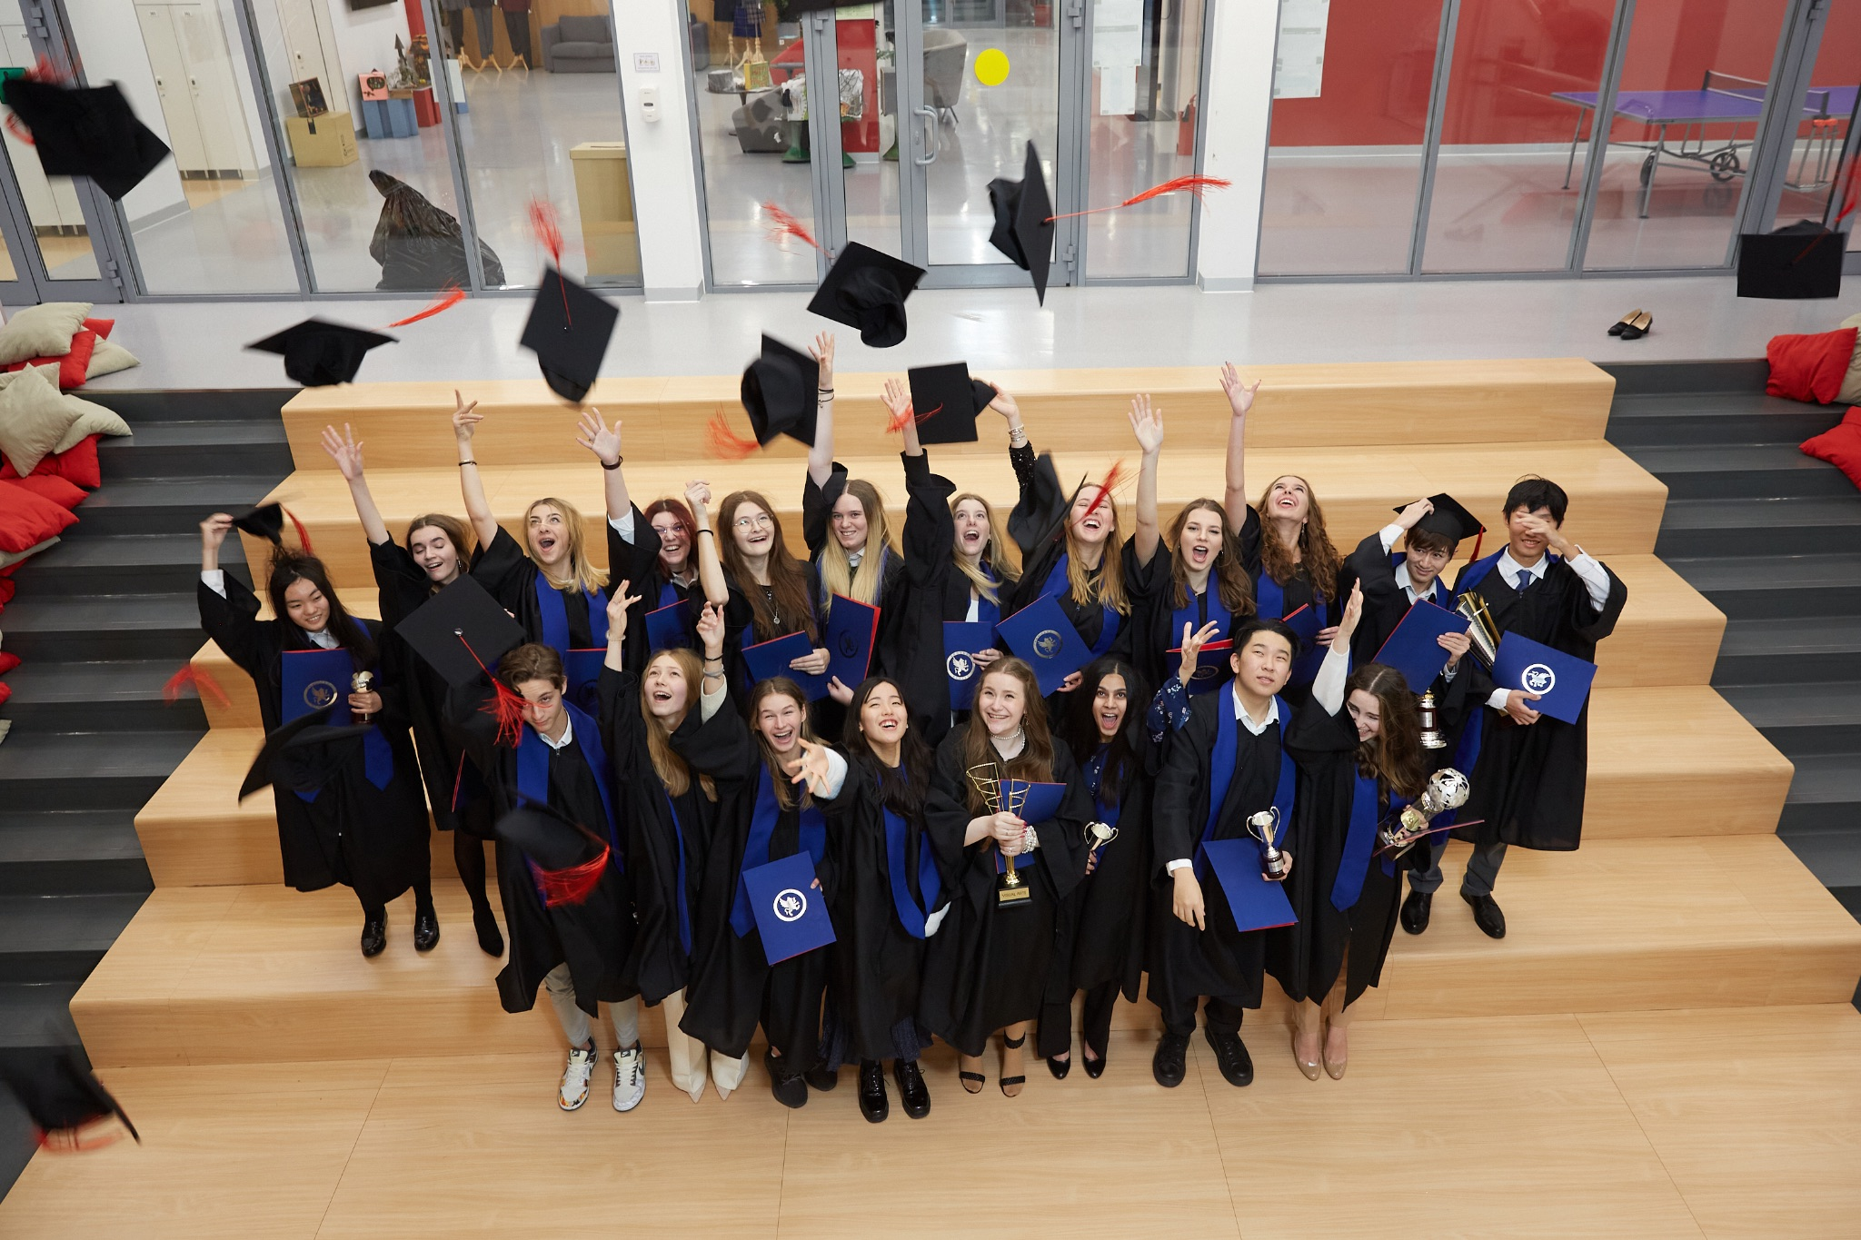
Brookes Moscow is a member of the Brookes Education Group (BEG), a global family of IB World Schools, that cater for local families and expatriates. Brookes Moscow opened its doors to students in September 2018 to offer full education based on the International Baccalaureate curriculum to children from 2 to 18 years old. In May 2022 we have our first ever Diploma Programme examinations and will celebrate our first graduating cohort at the end of this academic year.
The Moscow campus is located in a green area of the city, Botanical Garden (12km from Red Square). The newly built campus in Moscow is a state-of-the-art building, with outstanding facilities that offer places for 700 students.
We are an inclusive school that caters to a range of needs and abilities. Our mission is to support students in a caring environment and give them opportunities to learn about themselves and to take action in areas they are passionate about.
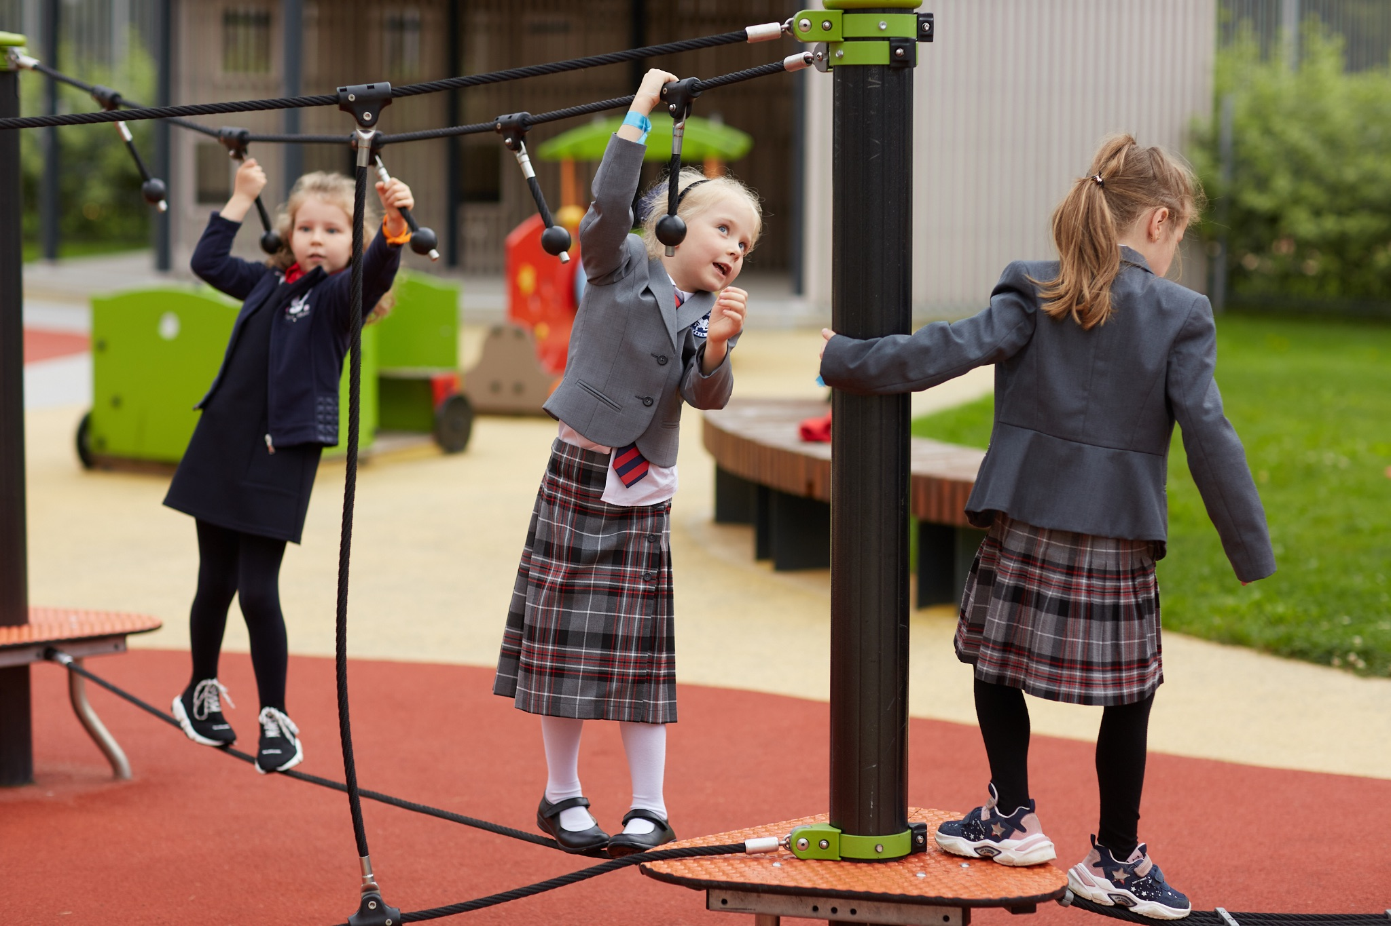
We believe that our main asset is our multicultural staff, people who can maintain a warm, welcoming and inspiring environment, who are interested in constant professional development and who contribute to and enhance our success.
We believe in the IB philosophy and teach all three programs PYP, MYP and DP through English.
Therefore, we look for talented, professional, ambitious and positive-thinking people to join our team and share our values.
If you are interested in working with a dynamic, unique and fast-developing international school, please apply below (employment@moscow.brookes.org)!!

For more information please visit - www.moscow.brookes.ru

Job Profile – Mathematics Teacher

The position of DP Mathematics Teacher reports to the Head of Upper and Senior School. The teacher of Mathematics is required to create a positive and supportive learning environment and develop activities so that students are able to practice in a meaningful context. The successful candidate will be expected to deliver Maths to MYP and DP students with a range of different abilities and capabilities.

Essential Requirements

- Fully Qualified Teacher with 5 years minimum of IB MYP and/or DP teaching experience;
- Degree in Mathematics or a related field;
- Expertise in teaching and assessment of the relevant subject;
- Adaptable and flexible to the requirements of the school;
- Commitment to the values of the continuum of an International Baccalaureate education;
- A consistent commitment to high levels of pastoral care;
- Fluent verbal and written communication skills in English;
- Ability to be flexible in an ever-changing world of education;
- Positive and innovative mindset even in challenging situations;
- Expectations of high standards of learning and behaviour from students; and the ability to challenge all students on an individual basis;
- A willingness to contribute to the wider school community;
- Caring nature towards students and families;
- Excellent organisational and time management skills;
- Excellent interpersonal skills, and the ability to work collaboratively with teachers, students, parents and staff;
- Compliant with Child Safeguarding Requirements

Desirable Requirements

- No less then 2 years’ experience with MYP/DP Examinations;
- Experience with using ManageBac

Responsibilities

- To maintain and deliver the IB MYP/DP Maths curriculum as well as the curriculum for any other courses assigned;
- Take the lead from Programme Coordinators with regards to unit planning, assessments and recording evidence of learning;
- Collaborate on a regular basis within subject groups and across subjects, for the purposes of horizontal and vertical planning;
- Effective use of ManageBac for unit plans, recording evidence of learning and student feedback;
- Promote a safe working environment for students and staff;
- To promote the ideals and mission of the school and our three pillars, Creativity, Character and Connectivity;
- Contribute to the school community by being a team player willing to collaborate with a diverse group of teachers and staff members;
- Take into account the different ability levels of students and differentiate work accordingly;
- To offer students every opportunity to engage in learning during all lessons and/or activities;
- To manage students’ conduct by promoting positive behaviour;
- Be a role model for children.

Benefits

- Competitive pay and compensation package;
- Annual performance related bonus;
- Free breakfasts & lunches;
- Housing provided;
- Travel allowance;
- Relocation support (visa and tickets);
- Medical & Dental insurance;
- Use of Sports Facilities in School - Swimming Pool, Gym, Team Games;
- Russian lessons are available;
- Additional activities and corporate discounts outside school.

